How to get reelected if you are an Iranian MP
By Paasha Mahdavi
Washington Post, 2015

In just over six months, Iranians will go to the polls for the first time since the signing of the Joint Comprehensive Plan of Action (JPOA) nuclear deal in Vienna on July 14, 2015. The Feb. 26, 2016, round of parliamentary elections will serve as the first formal litmus test of voters’ approval or disapproval of the nuclear deal and its aftermath. With election campaigning andnominations underway, the perennial question for today’s representatives is: Will they remain in office or be cast out?

Since 1980, less than 30 percent of politicians running again in Iranian parliamentary elections retained their seats. Compare that to more than 90 percent of incumbents in the U.S. House of Representatives and the U.K. House of Commons who were reelected over the same period. How is this possible? How can it be harder to get reelected in an authoritarian state like Iran than in a developed democracy like the United States?
Not all incumbent members of parliament (MPs) in Iran are destined to be voted out. In fact, some MPs have stayed in office since they were elected in the early 1980s. The two factors that explain success are surprisingly similar to those that matter for elections in developed democracies.
The first is money — specifically how much MPs have been able to spend on their districts in the years preceding an election. This should come as no surprise to anyone paying close attention to politics: pork-barrel spending on constituents wins elections, whether it’s a senate race in Louisiana, parliamentary election in India or presidential campaign in Brazil.
The second is electoral law — specifically how visible incumbents are to their constituents and how much credit or blame voters can assign them for their performance in office. This is again fairly intuitive: rules that favor local accountability lead to personal connections between voters and politicians, helping these incumbents maintain their seats in parliament or congress.
In any democracy, these findings may not be surprising, but context here is key: The fact that money or electoral rules have anything to do with winning elections in Iran is notable. In an authoritarian regime controlled almost entirely by clerics, one might expect Islamic ideology and close ties to ruling members of the regime to matter most for parliamentary reelection. Though these factors are also important– after all, candidates must pass through a brutal vetting process before running– rules and accountability matter much more than anticipated, as Iran is hardly a functioning advanced democracy.
In research recently published (ungated) in World Politics, I examined this issue by studying patterns of election outcomes for incumbents seeking reelection to Iran’s 290-seat parliament (which has increased to 310 for the upcoming election). I found that MPs in districts rich in natural resource production are more likely to get reelected into office, especially when resource revenue is used to provide schools, hospitals, infrastructure and jobs to voters. Incumbents in resource-poor districts do not have the same opportunities to spend on their voters. Not surprisingly, they are routinely cast out of office in favor of other challengers. A similar “incumbency disadvantage” has also been noticed in places like Brazil, India and Eastern Europe.
The distribution of natural resources varies greatly across the country, as shown in the map below. Most of Iran’s resource wealth is stored in two provinces, Khuzestan and Kohgiluyeh-Boyerahmad, which sit atop the vast majority of the country’s onshore oil and gas fields. Beyond these two, however, there are a handful of other provinces rich in minerals as well as petroleum, such as Bushehr, Fars, Ilam and Kerman. This variance in natural resource wealth allows for a comparison of election outcomes across regions to test whether or not resources play a role in improving the lot of incumbent MPs.

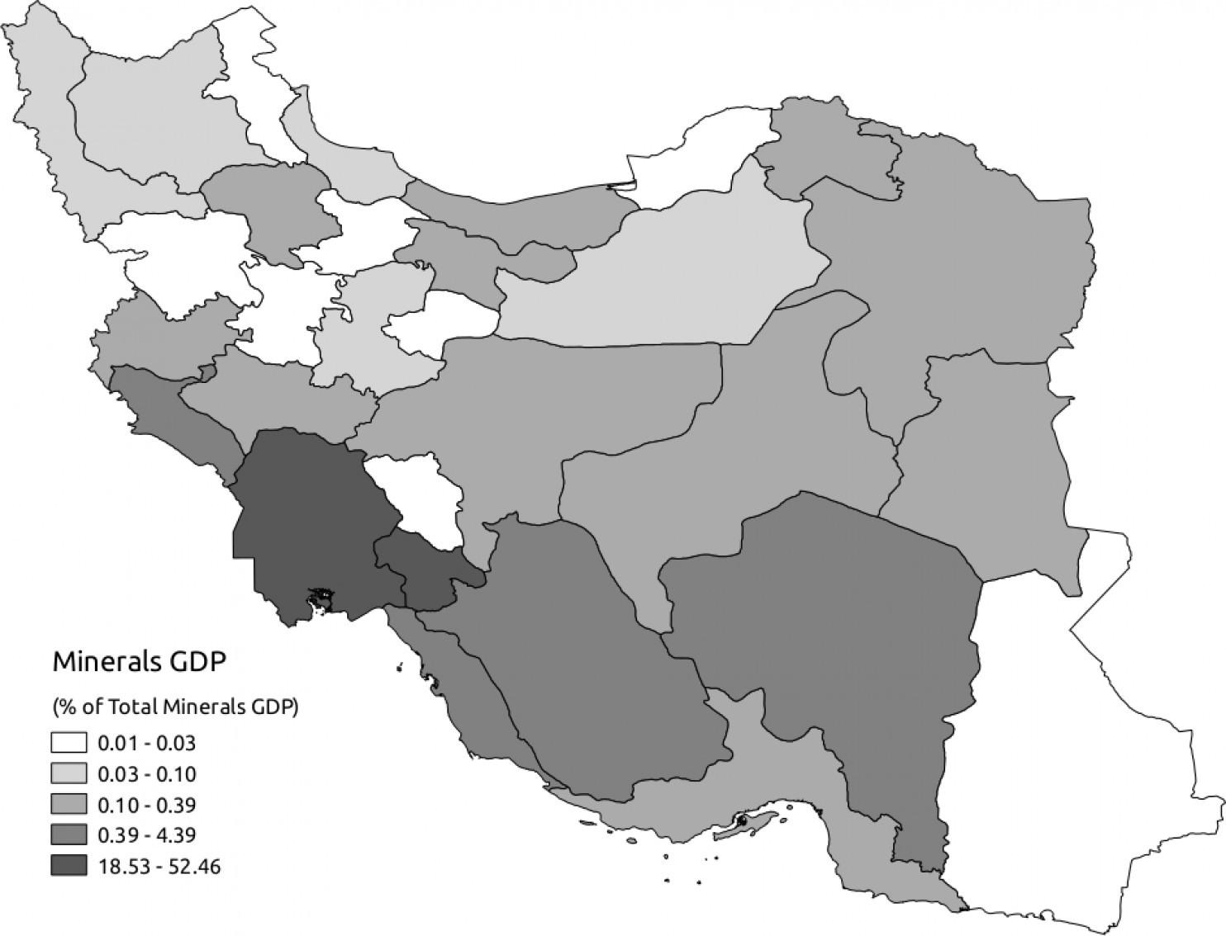
Geographic distribution in 2008 of natural resource wealth by province as percent of national natural resource gross domestic product, ranging from 0.01 percent to a maximum of 52.46 percent (the maximum value across all years is 65.28 percent, occurring in Khuzestan province in 1995). Data: Ministry of Interior. Figure: Paasha Mahdavi.
Iran’s parliament is elected by what political scientists call a “mixed-member system.” Some districts only elect one representative while others elect two or more. The division between single-member and multi-member districts offers a chance to study not only the effects of natural resource wealth, but also how electoral rules effect how long politicians remain in office. My argument suggests that the effects of resource wealth on reelection are strongest where the MP is the most visible to voters. In single-member districts, a politician can reap the full reward of doing right by her district, without having to share the glory with other MPs in office. On the other hand, an incumbent failing to appease his voters cannot place the blame on other MPs. In this way, the single-member district makes the MP most visible to his or her voters for better or worse.
I analyzed the results from four consecutive parliamentary elections to find that MPs running for reelection in resource-rich districts fared better in the polls than those running in resource-poor districts. This effect was even stronger for incumbents competing in single-member districts. Specifically, results from a statistical analysis of 1,075 district-level elections indicate that a single percentage point increase in natural resource revenue increases the chances of an incumbent MP’s reelection by 3.7 percentage points in single-member districts.
Interestingly, the religious ideology of the candidate had no relationship with incumbent reelection— in fact, the number of incumbents who are also Islamic clerics, or seyyeds has declined from 81 in 1988 to 36 in 2012.
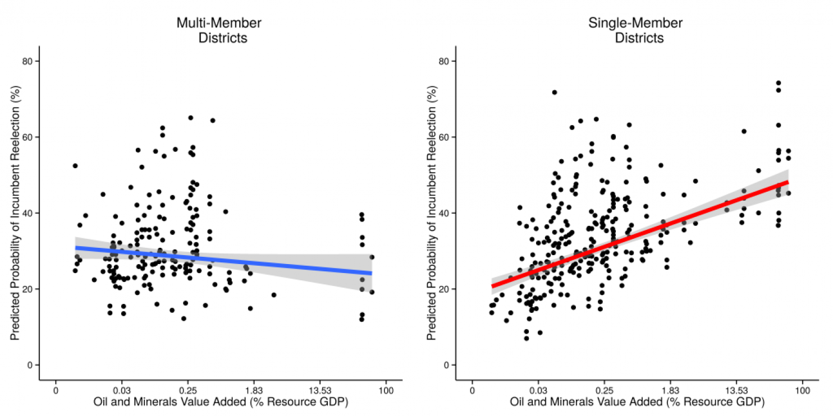
Natural resource wealth increases predicted incumbent reelection rates, but only in single-member districts. Predicted rates calculated from a mixed-effects regression model controlling for candidate-, district-, and province-level factors. Data: Ministry of Interior and Islamic Consultative Assembly of Iran. Figure: Paasha Mahdavi.
What drives this pattern? Revenue allocation flows from Tehran, to the provinces, then the districts where it is allocated by MPs for the purchase of much-needed goods and services, such as hospitals, schools and state-sponsored employment at the local level.
How politicians spend this money is what keeps them in office. I analyzed annual records of the number of schools, hospitals and jobs created in each province from 1998 to 2008. Based on these data, it would seem that resource revenue is being used to provide goods and services to voters: the more resource-rich a province is in a given year, the more hospitals, school teachers, and general state-sponsored employment are allocated to that province both in terms of the levels of goods and four-year changes in these levels.
Take the case of two similar districts in southwestern Iran: Shadegan in Khuzestan Province and Borujen in Chaharmahal and Bakhtiari Province. Both are single-member districts with populations of approximately 50,000; both are ethnically heterogeneous mixes of Persians, Arabs, Lurs and Kurds; and both had one-term incumbents running for reelection in 2008. One thing differentiates the districts: whereas Borujen is resource-poor, Shadegan is home to the Shadegan oil field, which produces 47 thousand barrels per day (1.2 of Iran’s total daily oil production).
Using $1.5 million in funds reallocated to Shadegan based on its oil revenue, incumbent MP Majid Naserinezhad initiated more than 90 public works projects in the district, including three large-scale water wells, a medical center and 14 schools. In Borujen, incumbent MP Gholamreza Mirzaei could not even obtain $500,000 for desperately needed repairs to 15 public bathhouses (a staple of daily life in this region). Not surprisingly, Naserinezhad was easily reelected, while Mirzaie lost to newcomer Cyrus Barna Baldaji.
The benefit of natural resource allocation may be even more valuable now, asthe rollback of oil sanctions will undoubtedly increase Iranian oil revenue. Without this revenue lifeline, representatives like Mirzaei face an uphill challenge retaining their positions.
So what does this imply for studying differences between authoritarian states and advanced democracies? Authoritarian regimes like Iran– or Hosni Mubarak’s Egypt, Jordan or post-Soviet states for that matter – can have institutions that closely resemble those in democracies, especially as authoritarian regimes modernize.
They can even have more highly competitive elections than those in democracies, resulting in greater upsets for incumbents. Come February, we will see whether this disadvantage remains for sitting parliamentarians — or whether voters will reward incumbents if Iran’s economy bounces back in the wake of the nuclear deal.
Paasha Mahdavi is an assistant professor at the McCourt School of Public Policy at Georgetown University. You can follow him on twitter@paashamahdavi.

