The Economist’s 2015 Special Report on Nigeria

- Opportunity knocks
- We happy few
- Miracle in Abuja
- After oil
- Secret weapon
- Can’t spend, won’t spend
- The only thing that works
- Keep it calm
- Down on its luck
- Can he do it?

Nigeria: Opportunity knocks

Having consistently failed to live up to its huge potential, Nigeria now has a rare chance to turn itself round. Jonathan Rosenthal assesses its prospects
“CHANGE”. THE ELECTION-CAMPAIGN slogans of the All Progressives Congress (APC) emblazoned on large billboards across Nigeria in March were light on policy prescriptions. Nigeria’s main opposition group at the time, and now its governing party, offered a simple promise: it would be bound to be better at governing Africa’s most populous nation than the incumbent government of Goodluck Jonathan and his People’s Democratic Party (PDP). “A lot of people were in the anybody-but-Jonathan camp,” says a prominent Nigerian businessman. Yet in the days before the vote on March 28th, amid fear of violence and talk of another military coup, many Nigerians would have been happy just to see a peaceful outcome. The previous election in 2011, Nigeria’s least violent in recent years, still claimed some 700 lives in outbreaks of violence across the north.
So Nigerians’ expectations were limited, which made the latest election all the more remarkable. In the face of vigorous attempts by both parties to rig it (with the PDP seemingly somewhat better-resourced and more successful at it), Nigeria’s independent electoral commission presided over a vote that was the country’s freest and fairest in decades and could broadly be said to reflect the will of its people.
More significant still was the result. The election of Muhammadu Buhari, a former military strongman, marked the first time in Nigeria’s 55-year history as an independent state that a ruling party was ousted by the ballot, not the bullet. After being governed by military dictators interspersed with elected politicians (see chart), Nigeria confounded the world by showing that a fragile democracy had taken root. Among the most surprised were leading figures in the PDP, which had held power since the end of military rule in 1999, successfully rigged every election since and fully expected to do so again.
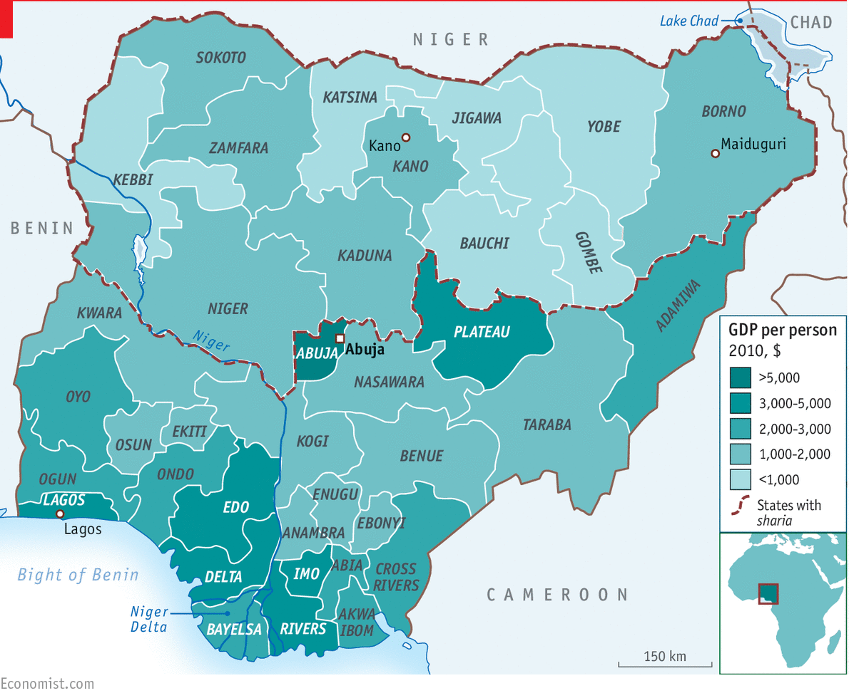
The change in government has brought a new sense of optimism to a country that has generally failed to live up to its enormous promise. The one bright spot in recent years has been Nigeria’s rapid economic growth, averaging over 7% a year over the past decade, making it one of the world’s fastest-growing economies. Last year the country’s statisticians recalculated its GDP figures to take account of new industries such as mobile telecommunications and discovered that it had become Africa’s biggest economy, ahead of its main economic and geopolitical rival, South Africa.
Yet the benefits of that growth have been unevenly distributed and the economy has failed most of Nigeria’s people. The impressive growth rates hide a series of government failures that have held the country back from achieving its potential. Economists reckon that it could be growing about four percentage points a year faster, a rate that would allow GDP to double every six years or so. Such growth is desperately needed in a country where tens of millions still live on less than $2 a day.
Nigeria has vast oil and gas wealth, fertile soil, untapped mining riches and entrepreneurial people who excel abroad. But at home poverty has barely declined, inequality is rising and corruption is rife. A country that should be the region’s breadbasket cannot even feed itself. It ought to be Africa’s biggest oil and gas producer, yet it suffers crippling fuel shortages and the whole country produces only as much electricity as a single medium-sized European city.
And even such economic growth as it has achieved in recent years is now under threat. Lower oil prices will reduce growth by about one-third this year. They will have an even greater impact on the government’s finances, which still depend largely on oil, trimming its revenue by almost 40%. Many of Nigeria’s states are bankrupt, and the new government has inherited massive unfunded liabilities.
Worse, an insurgency in the north has claimed about 20,000 lives and forced some 1.5m people from their homes. Just a few months ago Nigeria seemed to be at risk of fragmenting. Most of three states in the north-east, Adamawa, Borno and Yobe, covering an area about the size of Belgium, were under the control of Boko Haram, a jihadist group bent on murdering and raping its way to the establishment of a self-proclaimed “caliphate”. A siege of Maiduguri, the capital of Borno state, and fighting in its streets in January raised the prospect that it might fall. The loss of a city of almost 2m people would have forced Nigeria’s army to cede much of the north to the jihadists.
The turnaround has been extraordinary. An offensive against Boko Haram that got under way in February has driven the militants from most big towns and pushed them back into a few forest and mountain redoubts. Mr Buhari, who enjoys wide respect within the army, has promised to pursue this campaign with vigour. His asceticism and intolerance of corruption were on display even before his inauguration. One of his first orders was that his motorcade should obey the rules of the road and not inconvenience other drivers by blocking crossroads so that he could whizz through.
Quick, hand me my moral compass
Kleptocratic ministers and state governors who had expected another term at the public trough were soon looking for safe havens at home or abroad. Billions of dollars that had been stolen from the public purse were said to be making their way back. Officials were negotiating amnesties in return for handing back their loot, driven by a new fear that rules long put aside when Mr Jonathan was in office would now be enforced. “A lot of guys I know are getting their income tax in order,” says one Nigerian businessman. Civil servants have taken to turning up for work at 8am sharp instead of shambling in hours later.
That spirit of change has spread through the ranks of the country’s businessmen too. Investors are dusting off business plans for factories, hotels and shopping malls that had been languishing because the bribes to get them going had proved too much, or because they feared someone else might pay bigger ones. Foreigners have been snapping up Nigerian bonds and shares again, hoping that Mr Buhari’s government will revive economic growth. Even women selling groceries in the markets are filling up their stalls again, having run down their stock before the election because they feared it would be looted.
This report will argue that at last Nigeria has a realistic chance of fulfilling its potential. For that to happen, the new government has much to do, perhaps too much. It needs to focus ruthlessly on a few areas where it can make a difference quickly. The most urgent of these will be to improve security, not just in the north-east but also in the fractious “middle belt”, a stretch of states that more or less bisect Nigeria from east to west, as well as in the Niger Delta.
Mr Buhari will also need to restore faith in the institutions of government by clamping down on corruption. A good way to start will be to end energy subsidies that have become a perfect breeding ground for graft as well as a drain on the public purse. To unleash growth, he should forget about plans to promote industry by imposing high import tariffs, and instead concentrate on helping farmers get their crops to markets. With less meddling in markets and more private investment, electricity generation could quickly double. Given cheap and reliable energy, other parts of the economy, from manufacturing to film-making and e-commerce, could take off. But none of that will happen without a clean-up of Nigeria’s rotten politics, dominated by political “godfathers” whose interests lie in preserving the status quo, not the change that a majority of Nigerians voted for.

Miracle in Abuja

A largely democratic and peaceful handover of power

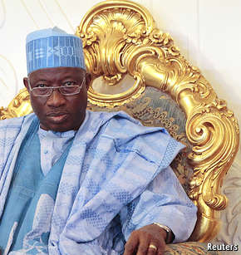
“THEY RIGGED AND rigged right until the very last moment,” says one Western diplomat of Nigeria’s March election. A variety of techniques were employed. First, the police and the army insisted on the election being postponed by six weeks, arguing that they needed extra time to ensure security. But most people believed that the delay was instigated by the ruling party, which feared it was at risk of losing and hoped that this would give it more time to buy votes. More blatantly, states around the Niger Delta saw ballot-box stuffing and submission of false counts, and across the country bags of cash were being handed out to prospective supporters. As a result the local currency, the naira, weakened as politicians converted it into dollars. These came in high denominations, taking up less space in the suitcases used to cart them about on the campaign trail.
To be fair, both sides were guilty of malpractices. Observers in the north say that supporters of the governing PDP were threatened, and many stayed at home. Some also reported seeing large numbers of children voting for the winning APC. All the same, the outcome broadly reflected the will of the electorate in what most observers said was the fairest election in decades—even though some informed sources reckon that a more accurate count of the vote would have delivered about 60% of the total to Mr Buhari, rather than the 54% he was officially credited with. So how did democracy triumph against the odds?
Much of the credit goes to Attahiru Jega, a soft-spoken academic who was put in charge of the independent electoral commission in 2010. His appointment came too late to influence the 2011 election, but he has spent the past five years cleaning up the voters’ roll and introducing electronic ID verification that makes it much more difficult to stuff ballot boxes. He has also proved to be stubbornly non-partisan, to the chagrin of many in the PDP.
A second factor was the PDP’s sheer incompetence. With little leadership or direction emerging from Aso Villa, the presidential compound, the party had become so weak in government that it seemed incapable of defending its position. “They were too incompetent even to rig the election properly,” says one insider.
Third, many voters had become deeply frustrated with Mr Jonathan’s government and were desperate for change. Tempted by the ruling party’s bribes, they may have worked out their own moral compromise. As one observer put it, “people took the money and then voted their conscience.”
Last, across the country independent monitors kept an eye on the polling stations. Many took photos of the results recorded at each station and posted them on social media, making it difficult for officials subsequently to fiddle with the numbers. Others submitted results to a parallel vote count run by the Transition Monitoring Group, a non-government organisation. This flagged up instances of ballot-box stuffing by the PDP in the Niger Delta and helped limit its extent. It also encouraged the police and army to stay largely neutral, even as senior figures within the PDP tried to get them to take sides. Pressure from abroad, mainly America and Britain, played a part too.
Though Mr Jonathan’s presidency was in most respects a failure, even his sternest critics give him credit for stepping down quickly once it became clear he had lost, even before the final tally was in. In doing so he pulled the rug from under senior PDP members who were said to be plotting to try to keep the party in power. One plan was to try to kidnap Mr Jega to disrupt the count, according to Reuters, a news agency.
The democratic outcome, however tenuously achieved, sets an important precedent. Having spent the past 16 years under the rule of a single party, and most of its history before that under military rule, Nigeria has matured into a multi-party democracy that is not ruled along ethnic or religious lines. The PDP, for all its failings, was a largely national party. When it came to power in 1999 under Olusegun Obasanjo, it managed to unite the country’s north behind a president from the south. Mr Obasanjo, a Yoruba-speaker from Ogun state in the south-west of the country who had ruled as military dictator in 1976-79 before handing over to a short-lived civilian government, managed to win the trust of northerners.
North v south
Nigeria’s population is about half Muslim and half Christian, and for some time it was widely argued that the PDP was the only party that could overcome the country’s religious and ethnic divisions, not least thanks to its policy of “zoning” whereby the presidential candidates it nominated would alternate between northerners and southerners. The opposition, by contrast, was seen as dominated by northerners and Muslims, who are concentrated in the north and west of the country, and was divided. That changed in 2013 when the three biggest opposition parties joined to form the APC, offering policies slightly to the left of the PDP’s.
Yet despite the apparent victory for democracy, concerns remain. In his previous terms as a military ruler, Mr Buhari was no democratic pin-up. He banned political meetings and free speech, executed people for crimes that were not capital offences when they were perpetrated and sent whip-wielding soldiers onto the streets in a “war against indiscipline”. Mr Buhari has since said that he is committed to democracy, but many Nigerians fret that he may try to rule by decree. Before his inauguration he threatened to expel critical journalists from press conferences, but his party did a swift about-turn on that.
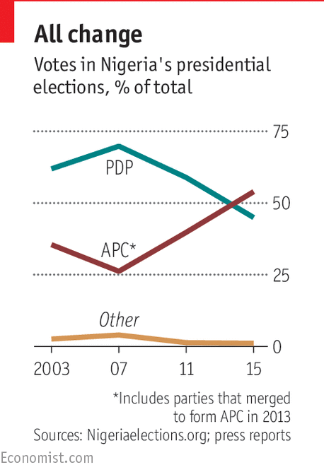
Even if democracy has now taken root at the centre, it has yet to establish itself in state governments, most of which are little more than the fiefs of their governors. State governors often control the party apparatus in their states and thus dole out seats in the assemblies to loyal followers, and the state assemblies that should hold the executive to account are often vehicles for patronage. Many local governments are still more of a mess. There may be a need for constitutional reform to make all levels of government answerable to the citizens as well as to clarify how powers are to be divided among states and central government.
The election also highlighted the urgent need for political reform, not least in campaign finance. Contesting elections in Nigeria costs a fortune. Rigging them costs even more, leaving presidents and state governors in hock to various “Ogas”, the local slang for big-man or godfather. Ngozi Okonjo-Iweala, a long-standing PDP finance minister, recalled in her memoir, “Reforming the Unreformable”, that in the latter part of Olusegun Obasanjo’s second presidential term, in 2006, businessmen and party patrons asked her to waive a 50% tax on imports of rice. She reckoned such a waiver might be worth $1 billion to the importers and party funders, but would ruin many rice farmers who had been encouraged to plant by an import-substitution policy that included hefty tariffs. So she refused, and was kicked out of the finance ministry soon afterwards.
Keeping the Ogas at bay
The way Nigeria’s main political parties are run, too, needs to be made more democratic. Voters get to vote for one presidential candidate or another, but there is very little transparency over how each party selects its nominee. For the two main parties this is meant to be done at party congresses, yet there is talk of bidding wars as Ogas buy votes for their preferred presidential candidates. Once in office, politicians can dispense patronage to their supporters and influence legislation to benefit their Ogas. One solution might be to move to American-style open primaries in which voters elect their parties’ candidates directly. If overseen by an independent electoral commission, such primaries might make parties more responsive to voters and force them to come up with new ideas and policies. Nigeria’s recent election was fought mainly on perceptions of which candidate would be more effective and less corrupt, rather than on their policies or ideologies. But policies also matter, not least on how the government collects and spends money

The economy: After oil

The oil shock has left a deep hole in the government’s finances, but the economy is beginning to diversify

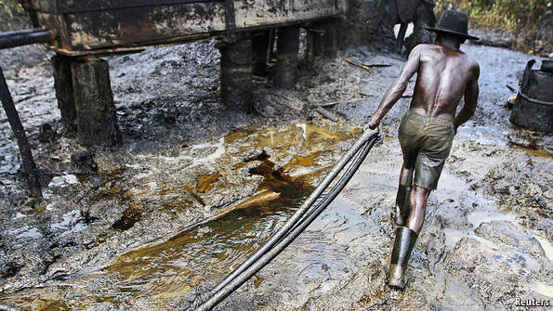
IN THE DAYS before Mr Buhari’s inauguration, wags in Abuja’s watering holes were joking that the new finance minister would find a note on his desk: “Sorry, there’s no money left.” They had a point: lower oil prices and the profligacy of Mr Jonathan’s government have hit Nigeria’s finances hard.
Oil contributes only about a tenth of Nigeria’s GDP, but directly accounts for around 70% of government revenue. Add in indirect taxes, and its contribution rises to about 85%, government officials say. When oil prices were high, there should have been plenty of money to run the country while also saving for a rainy day. Yet over the past two years the government spent when it should have saved.
Government officials are now frantically trying to plug the gaping hole in the public finances that the fall in oil prices has opened up. The value of Nigeria’s oil exports is expected to drop to about $52 billion this year, from $88 billion in 2014. Government revenues will decline by about 40%, and spending will slump. Economic growth is expected to slow to about 4.5% this year, from an average of over 7% a year during the past decade. The government’s capital spending will probably fall by more than half, halting construction of desperately needed roads, bridges and railways.
These difficulties are compounded by the state governments’ murky finances. Some analysts reckon that more than half the states are bankrupt. Many have not paid civil servants’ salaries for three months or more. Lower oil prices also threaten to spill into other sectors of the economy. Consumer spending, much of which is kept going by civil-service salaries, has stagnated. Banks face a wave of bad debts from Nigerian oil firms that bought oilfields when prices were high and are now struggling to repay their loans. In short, Nigeria risks repeating a pattern of wild swings in growth caused by gyrations in the oil price.
Aside from facing an immediate cash crunch, the government will find it hard to fund the new programmes it is hoping to introduce. Mr Buhari has outlined an ambitious programme aimed at reducing extreme poverty. These include a scheme to provide conditional social grants for the country’s 25m poorest people (modelled on Brazil’s bolsa familia scheme), payable if families do sensible things like enrolling children in school and having them immunised, which will cost some 1.25 trillion naira ($6.3 billion) a year.
APC officials say they hope to find the required cash through a combination of plugging “leakages”, short for corruption and waste, and new taxes. An obvious place to start would be subsidies on petrol. Nigeria spends about $6 billion a year (about 1% of its GDP) on these and about half as much again on kerosene, used by the poor for cooking and lighting. Yet it does not appear to be getting value for this money. Subsidised kerosene is nowhere to be seen: many think it is swiftly resold to airlines as jet fuel. Petrol, which is meant to sell in Nigeria for 87 naira ($0.43) a litre, is often smuggled to neighbouring countries where it fetches a higher price. For much of this year Nigeria has been suffering from dire fuel shortages that have forced residents to queue for hours, sometimes days. Traders on the black market, meanwhile, do brisk business selling the stuff for 200 naira a litre outside the official stations, and a lot more at times of extreme shortage.
The new government also urgently needs to reform a tax system that collects much less revenue from companies and from value-added tax (VAT) than do most other developing countries. That is because taxing stuff that comes out of the ground is a lot easier than getting people to hand over some of their own hard-earned cash. Nigerians have long tolerated the theft and squandering of oil wealth, but if the government wants to spread the tax net more widely, it will have to show that the money will not simply leak into the offshore accounts of politicians and senior civil servants.
Yet for all the short-term pain, Nigeria’s economy has made enormous strides to wean itself off oil in recent years. Almost half of its economic output now comes from services. Nollywood, the country’s home-grown film industry, has become the world’s second-largest by output. Innovative startups offering everything from fashion to software development are popping up all over the place, helping to soften the oil shock. And although the naira has fallen sharply against the dollar, food inflation has not speeded up as it usually does when the currency weakens because Nigeria has vastly expanded its own food production over the past few years. The finance ministry reckons that between 2009 and 2013 food imports declined by about $2 billion, to $4.3 billion.
Efficiency cubed
This is partly thanks to food factories like Nestlé’s in Nigeria’s industrial heart of Agbara, to the west of Lagos, one of the Swiss company’s largest. Together with a sister plant farther to the east, it ferments, mixes and presses some 90m soup cubes a day, about one for every two Nigerians. The management is facing the usual problems with infrastructure: it has to generate its own power, clean up its own water and provide health care for its employees, and poor transport links drive up the cost of its raw materials. Even so, it is one of the company’s most efficient factories on the globe, in part because of the benefits of scale from producing a narrow range of products for a huge market. It is also stupendously profitable. Return on investment at Nestle’s Nigerian subsidiary is twice as high as for its global parent.
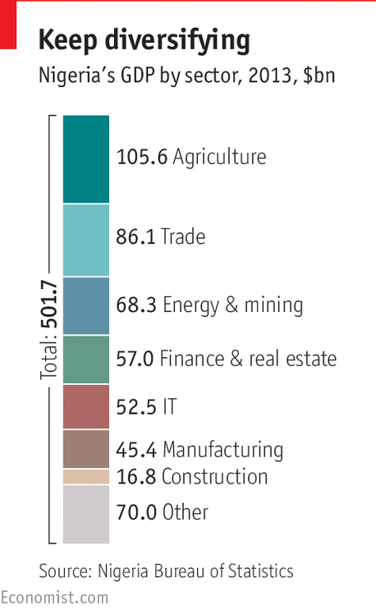
An economy that has doubled in size over the past decade is an irresistible target. Verod, a Nigerian private-equity firm, has earned some 15 times more than it spent on building Nigeria’s first factory to make drinks cans. It is now investing in fruit-juice makers, a fish farm and a packaging firm. “Our business model is to look for anything that comes into Nigeria by boat and asking if we can make it more cheaply here,” says Danladi Verheijen, the firm’s co-founder and a graduate of Stanford and Harvard Business School. IHS, a firm that is buying mobile-phone towers and managing them more efficiently, has raised more than $5 billion in debt and equity over the past few years.
The proliferation of consumer industries in Nigeria is transforming its economy in more ways than one. The first, and most obvious, is that they are making its economy far less dependent on oil and therefore less vulnerable to oil shocks. Manufacturing now accounts for almost as big a share of GDP as oil, though there is more to do. Services, which include mobile phones and the like, make up about half the economy now. Nollywood employs about 1m people who between them produce some 50 films a week, and is winning viewers right across the continent.
This diversification is also driving a far more important change. As the country moves from pumping oil out of the ground to producing wealth through its industry and talent, it is creating a vast new middle class of entrepreneurs and professionals who want to make money through their own efforts instead of seeking government jobs to siphon off oil revenues.
Some industries in Nigeria still earn huge margins thanks to tariff protection and friends in the government. But in many areas tariffs are falling and new domestic competitors are emerging. Dangote Cement, a Nigerian firm, used to earn margins of more than 60% thanks to import curbs, but competition from other cement-makers, including Lafarge, a French producer with operations in Nigeria, has forced it to cut prices by more than 40% in recent months.
Government efforts to industrialise have not been blessed with much success. Nigeria has spent billions of dollars building vast steel plants that have yet to produce a bar of steel. It is now trying to encourage carmaking at home by levying import tariffs of up to 70% on imported cars. Official car imports into the country have fallen to about a third of their previous level, but those to neighbouring Benin, a minnow of 10m people, have surged to a level about three times higher than Nigeria’s, pointing to a flourishing car-smuggling industry.
Investment in agriculture seems a lot more promising. At independence in 1960 Nigeria was the world’s largest exporter of groundnuts as well as a leading cotton and cocoa grower, but output collapsed in the 1970s as rural infrastructure crumbled. Firms such as Nestlé are trying to buy more of their raw materials in Nigeria, including starch made from cassava, a drought-tolerant plant that produces large tubers. Nigeria is the world’s biggest grower of cassava, but does not do it particularly well: yields per hectare are a quarter of those in some Asian countries. As a result, most of what Nigeria produces is eaten as a subsistence crop on the farms where it is grown, and very little is processed into higher-value foods.
Researchers at the International Institute of Tropical Agriculture, a multinational research centre with headquarters in Ibadan, Nigeria’s third-largest city, have been working with Nestlé on developing high-yielding varieties of the crop and teaching farmers how to grow it. The results are impressive. On a lush green hillside in the institute’s grounds, Alfred Dixon, nicknamed “Dr Cassava”, points to plots of tall, green-leaved bushes that are producing 50 tonnes or more of cassava per hectare, about five times as much as the current Nigerian average.
McKinsey, a consulting firm, reckons that Nigeria could easily double its agricultural output over the next 15 years by introducing some simple reforms. To be fair to Mr Jonathan’s government, his agriculture minister, Akinwumi Adesina, one of the few stars in a generally lacklustre cabinet, had already started to introduce some of them. For example, he pulled the government out of the corruption-ridden business of distributing fertiliser and seeds to poor farmers, introducing smart cards and electronic vouchers distributed through mobile phones. Almost overnight he eliminated a major source of corruption and created booming private markets that attracted investment by big agricultural suppliers. That is reducing poverty, particularly in the restive north, and channelling raw materials into the sort of unflashy industrialisation that creates jobs.
Paradoxically, the depth of Nigeria’s fall is one of the reasons to be optimistic about its future: there is so much to be gained by getting just a few things right. Perhaps the most important of these is to improve its rural infrastructure so that farmers can get their produce to market, and to generate sufficient power to allow businesses to operate unhindered.

Corruption: The only thing that works

Changing an ingrained culture will take time

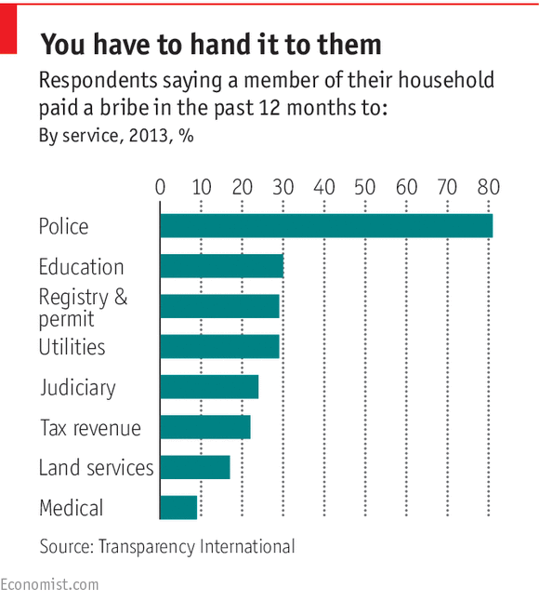
“WHAT HAVE YOU got for me this Sunday?” says the policeman, using his flashlight to tap on the window of your correspondent’s car at a roadblock in downtown Lagos, his AK47 dangling menacingly from one arm. Less than an hour earlier, an immigration official at the international airport had asked: “What have you brought me?” From the moment a traveller sets foot in Nigeria, he is confronted with the corruption that has afflicted the country for decades.
Nigerians are thankful for small mercies, and there has been some progress on fighting petty corruption. In the past travellers often faced harassment by policemen and officials if they refused to pay bribes, but your correspondent was told “you are welcome in Nigeria” whenever he politely declined to grease palms, including that of a guard at the central bank.
The improvement has several causes. First, the government has been trying to end the pervasive culture of impunity. Immigration officials’ names are now prominently displayed on counters, for instance, and documents are often scrutinised by two different people. Technology and social media play a part, too. Thanks to ubiquitous smartphones with cameras, every demand for baksheesh could quickly become a hit on YouTube. In one video, viewed more than 100,000 times, policemen demand cash from an American of Nigerian parentage. When their victim says he has no dollars, they amiably point him to a place where he can change money.
Several websites give victims a platform on which to complain. One such, stopthebribes.net, maps incidents of corruption. Another site, Nigeriapolicewatch.com, provided links to videos showing an armed and drunken policeman assaulting two young women that prompted an investigation by the inspector-general of police.
Yet even as petty corruption declined somewhat under the previous government, theft on a grand scale increased exponentially. “Under Jonathan everything was for sale,” says one local businessman. Although no one accuses Mr Jonathan of personal corruption, many mention demands for cash from those in his inner circle. One businessman says he was told, “don’t bring $20,000, bring $200,000.” One way to launder such loot was to buy property in Nigeria, where large transactions are often settled in cash. Another was to take it out of the country. “There was a chartered plane flying cash to Lebanon and Cyprus,” says one businessman. “They have houses full of cash.”
This penchant for cold cash was widespread. The chief executive of a large firm in Nigeria says that when he was invited into the study of a senior Nigerian politician, he saw bundles of dollar notes neatly stacked in the drinks cabinet. After Diepreye Alamieyeseigha, a former governor of Bayelsa state in the oil-rich delta, was arrested by British police on charges of money-laundering, they found almost £1m in cash in his London home.
The numbers involved in grand corruption in Nigeria soon become mind-boggling. Lamido Sanusi, a former governor of the central bank, claimed that over a period of about 18 months some $20 billion in oil revenues had gone missing from the Nigeria National Petroleum Corporation (NNPC), a state-owned firm that manages the government’s shares in oil companies and pays subsidies for fuel imports. Mr Sanusi was promptly fired for his trouble, but a public outcry forced the government to commission a forensic audit by PWC, an international accounting firm. Its report paints a picture of chaos and lawlessness within the NNPC. Billions of dollars were paid for subsidies on kerosene, yet none seems to have been sold at the subsidised price. It was generally available in markets for about three times the official price. In short, some $3.4 billion had simply vanished. Subsidies on petrol are only marginally better-managed.
Even murkier are losses of crude oil being pumped out of the country. Oil theft, which is euphemistically known as bunkering, is thought to account for anything from 100,000 to 500,000 barrels of oil a day, syphoned off from pipelines or illegally pumped. If estimates at the upper end of the range are correct, perhaps one in five barrels of oil produced in Nigeria is stolen. Such thefts require a huge infrastructure, which relies on the connivance of senior politicians and security officials.
Corruption trickles down through most arms of the government. Procurement contracts in particular are notorious for graft. The bigger the project, and the longer it takes to complete, the greater the opportunity to divert cash. Thus big projects in Nigeria routinely take far longer than planned and cost far more than originally budgeted. Many seem to have been built primarily for the purpose of stealing money. One state governor extolled the virtues of a large stadium he had built (“you can see it from space”), but seemed to have a poor grasp of economic indicators in his state, including poverty and literacy levels.
The good life, for some
Extravagant travel and living are two more ways of looting the budget. Many state governors and ministers fly around the world in private jets, stay in palatial mansions and drive expensive cars, all at the taxpayer’s expense. Bullet-proof sedans and SUVs are so popular that Nigeria has become the world’s biggest market for armoured cars, says one executive.
The legislature gets in on the act too. The chairmen of parliamentary committees routinely ask for kickbacks in exchange for an easy ride in hearings. Those who refuse to pay are pilloried. In one incident, screened on live television, the head of Nigeria’s Securities and Exchange Commission, Arunma Oteh, accused the chairman of the House Committee on Capital Markets of demanding bribes before the hearing. The chairman was charged with accepting $4,000 for a trip to a conference that he did not attend, but the court threw out the charges on appeal.
Shakedowns by local government often take the form of taxes and may even have a thin veneer of legality. Small businesses say they get stung for licence fees that are suspiciously negotiable and have a tendency to rise before Christmas and Easter, when officials need cash. In Lagos few firms display their names on their offices or factories because that would attract the attention of the Lagos State Signage and Advertising Agency, which would require many forms to be filled in and hefty annual fees to be paid. Other government agencies also put their hand out. The boss of one Nigerian consumer-goods company says he has to get the permission of eight government agencies each time he wants to run a promotion. The boss of another curses Nigeria’s lottery commission, which demands a fee worth 25% of any prizes offered to winners of promotions. Local authorities in small towns along major highways insist that lorries travelling through their territory must be licensed—for a fee. Such wheezes drive up the cost of distributing consumer goods by about a quarter, says the boss of one big firm.
The judiciary, which is meant to prevent such excesses, actually serves as a useful tool for extortion. One common practice employed by legal trolls is to wait until a large project such as a factory or apartment block is almost complete and then to ask the courts for an injunction against it being finished, often on spurious grounds. The courts may impose a temporary injunction that can take years to be reviewed and lifted. The quickest way to resolve these is to make a large out-of-court settlement.
It is difficult to find an arm of government that is not crooked. A survey in 2013 by Transparency International, a Berlin-based anti-corruption watchdog, found that large numbers of respondents had paid bribes to officials in the previous year (see chart, previous page).
Many of the institutions intended to fight corruption have themselves been compromised. The country’s most efficient anti-corruption agency is the Economic and Financial Crimes Commission (EFCC), but a weak judiciary and presidential pardons have undermined its successes. Its convictions are often overturned on appeal or end in a pardon. A striking example was that of Mr Alamieyeseigha (the man with the $1m cash stash in London). After jumping bail in Britain, he returned to Nigeria and was convicted by a court, but Mr Jonathan pardoned him.
Cleaning the stable
Many Nigerians also believe that anti-corruption investigations are used as a cover to settle scores and eliminate political rivals. Mr Buhari will have to ensure that such investigations are not partisan: a few scalps from each of the two big parties would send the right signals, as would a requirement for public figures to publish details of what they own. Mr Buhari has insisted that members of his cabinet do so. State governors, senators and members of the national assembly should follow suit.
Mr Buhari says that fighting corruption will be one of his main priorities, but it will be a long, hard slog, despite his own impeccable credentials. He leads an austere life and will not brook any excesses in his inner circle. According to one report, soon after his election he gathered his extended family together to tell them they could expect no immunity if they broke the rules. But many in his party, including some of those thought to have helped fund his campaign, may have had their fingers in the till. “By the time you’ve lifted the veil, you may be shocked by what you see,” says Bishop Matthew Kukah, a leading religious figure and moral authority in Nigeria. “This is not a country that is morally convinced about [the evils of] corruption: corruption is the only thing that works.”
In order to reduce opportunities for graft, Mr Buhari needs to go much further in making government transparent. The most shocking revelation at the NNPC was not that money had gone missing but that a state agency responsible for billions of dollars in revenue did not publish independently audited accounts.
The cost of all this graft vastly exceeds the actual amounts stolen. Investors are reluctant to put money into a country if they cannot be sure that contracts will be honoured. Local businesses deliberately stay small, hoping to stay beneath officialdom’s radar. Citizens are generally loth to pay taxes because they assume the money will be stolen. Billions of dollars in state spending are wasted on useless projects. On the outskirts of Sokoto in the far north of Nigeria a brand new power plant is going up, years behind schedule and over budget. The delay may be a mercy, for once it is switched on it will instantly start racking up big losses.
Graft has also been one of the factors behind an insurgency in Nigeria’s north which its army, hollowed out by corrupt generals, has struggled to contain.

Security: Keep it calm

Violence, mainly but not exclusively in the north, has exacerbated Nigeria’s many problems
THE GRAINY IMAGES looked like relics of a bygone era: white mercenaries riding on armoured vehicles through burned-out African villages. In fact, it was the characters themselves who were military relics. Many of the men recruited to fight Nigeria’s war on Boko Haram were in their 50s, veterans of apartheid South Africa’s bush conflicts in the 1980s. A good proportion were thought to have come from Koevoet, a special-forces unit in the South African police that ruthlessly hunted insurgents in what is now Namibia. Age may have wearied them, but not through lack of activity.
Many have been fighting on, more or less continuously, in almost every big conflict in the past three decades, including Angola and Sierra Leone and more recently Iraq and Afghanistan. This “army-in-a-box” was the thin khaki line that helped the Nigerian forces hold Maiduguri, the capital of Borno state. Only in January Boko Haram militants fought their way into the city, which has seen its population swelled by refugees to around 2m. That it did not fall also had much to do with Boko Haram’s strategic incompetence.
Last year the militants overran large parts of three states in the north-east of Nigeria and then spread chaos into neighbouring countries, attacking villages in Niger, Cameroon and Chad. They are said to be skilled tacticians who can rapidly concentrate their forces before dispersing again. Yet they seemed to have no real plan for what they would do with the territory they had conquered. Whereas the jihadists of Islamic State in Iraq and Syria established rudimentary administrations in their self-proclaimed caliphate, Boko Haram seems not to have bothered with governing at all. It routinely massacred villagers under its control and abducted women and children. Rape was not just ubiquitous, but apparently used as a weapon of ideological propagation: the militants are thought to believe that any children they father will inherit their jihadist beliefs.
Boko Haram had been successful in driving the Nigerian army from smaller towns and border garrisons, but seems to have had no clear strategy for Maiduguri beyond launching direct attacks on the city. For several months just one narrow road led in and out of the state capital. Although military supplies and reinforcements were airlifted in, the civilian population relied on the road for its food. Had the militants closed that road they could have starved the city out, which would have forced the army to abandon much of the north-east.
A combination of factors swayed the fight. The most important was support from Chad’s army, which wanted to keep the country’s own supply lines to the south open. It quickly cleared Boko Haram from border areas and then pushed it back from major towns inside the Nigerian border. The Nigerian army, too, upped its game, putting effective commanders in charge in the north-east and kitting out its soldiers with plenty of arms and ammunition. Intelligence support from Western allies also played a role, as did training provided by British and American soldiers. The trainers found that the recruits were eager to learn and to fight. This suggests that Nigeria’s army will, with some help, be able to take the lead in the north.
When Mr Jonathan delayed the election by six weeks from February to push back the insurgents, most people thought it was an excuse for more vote-rigging. Remarkably, though, that short period made all the difference. The election went off peacefully in most parts of the country. Boko Haram’s fighters have since been confined to remote areas, and thousands of women and children who had been taken captive have been freed, though 276 schoolgirls kidnapped about a year ago from a school in Chibok, in Borno state, have not been found (apart from a few who escaped). The government’s failure to recover them played a big part in Mr Jonathan’s electoral defeat.
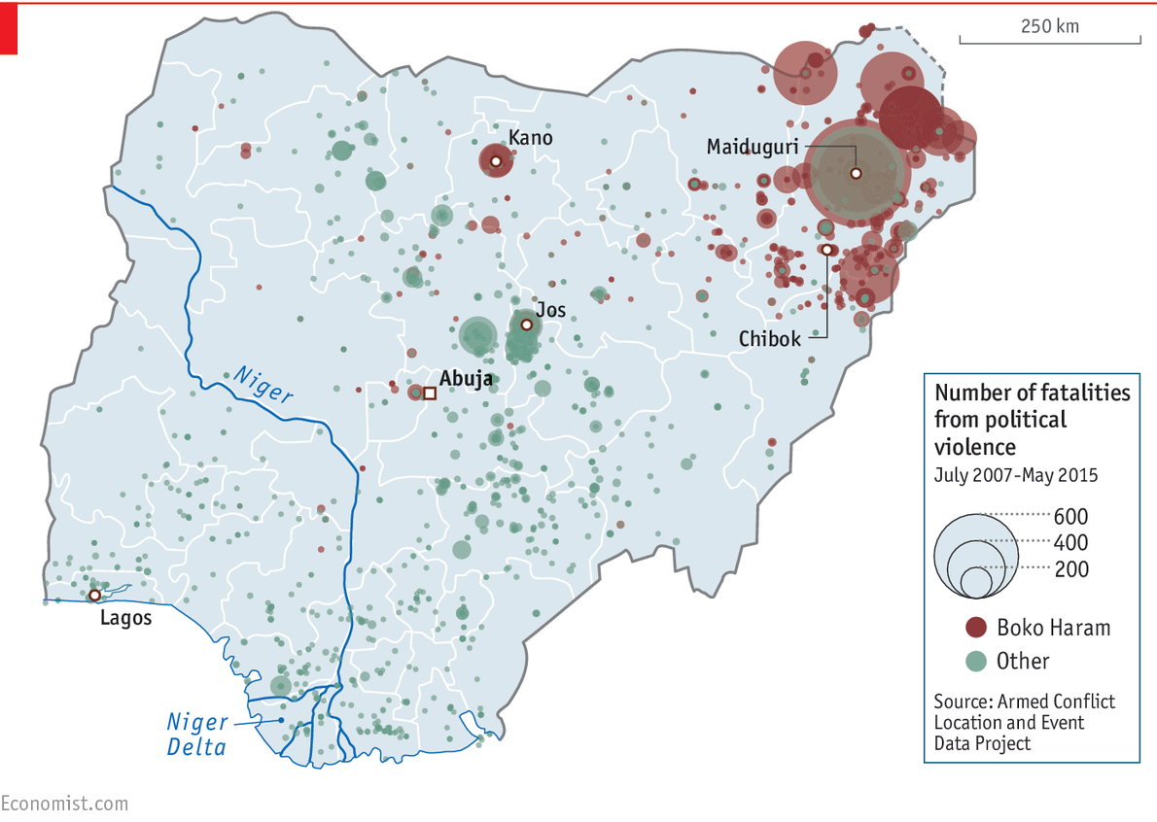
Despite Boko Haram’s recent setbacks, the fight is likely to drag on for some time. The rainy season will hamper the movement of soldiers into the mountains and forests where the rebels have taken refuge. More worryingly, the policemen who are supposed to secure liberated towns are woefully ill-equipped and undertrained. And this part of the country, already desperately poor before the insurgency, has now been totally devastated by it. Few schools and hospitals have been left standing. More than 1.5m people fled their homes, many of which have been burned down. “Think of South Sudan and Somalia and you’ll get the picture,” says one observer.
Quelling this insurgency and rebuilding the north-east will be one of the new government’s main priorities. As a northerner and a Muslim, Mr Buhari will have greater licence to use force than his predecessor, but he will have to rein in human-rights abuses by both the police and army or risk alienating many in the north-east, as well as Western allies who want to help but will not be party to war crimes.
Mr Jonathan’s government, for all its failings, launched an ambitious plan to counter the radicalisation of young northerners, including training religious leaders to speak up against jihadist ideology and helping people suffering from post-traumatic stress. An important part of the plan was to improve the justice system in the areas concerned. Thousands of young men who have been rounded up as suspected militants have been held for long periods without being charged and are rubbing shoulders with committed jihadists, so prisons have turned into radicalisation factories. In the longer term the government will need to undertake deeper reforms to contain radicalism, including making local and state governments more accountable, fighting corruption and eventually redeveloping the north to deal with some of the underlying causes of its wretchedness (see article).

Trouble, trouble everywhere
But the north is not the only trouble spot. In the Niger Delta, the source of most of Nigeria’s onshore oil and gas production, armed militants hold sway. In order to keep the oil flowing, the government and the oil companies have bought off criminal gangs in imaginative ways. The biggest of these was the Niger Delta amnesty, a peace plan unveiled in 2009 under which militants who handed in their weapons would be pardoned for their crimes and paid about $410 per month until they found legitimate work. Meanwhile many oil companies hired local groups to protect pipelines and oil wells. If such payments stopped, militancy would probably resume overnight.
Elsewhere in the country political violence is so widespread that it is barely reported. In the seven days from May 2nd this year, for instance, the Council on Foreign Relations, a think-tank based in New York, recorded more than 200 deaths in serious political violence throughout Nigeria. These included the killing of 80 civilians by soldiers in Plateau state in revenge for the killing of six soldiers by Fulani tribesmen in Taraba state a few days earlier. Sectarian violence elsewhere in Taraba in the week in question resulted in 21 deaths. The list continues, and this was by no means an extraordinary week: large parts of Nigeria’s so-called Middle Belt are riven by conflict and violence.
This takes many forms and involves many different groups, but it always involves a struggle over resources among desperately poor people in a country where peaceful means of dispute resolution do not exist and where nobody trusts state institutions. “A lot of communities have reserves of arms and access to people who know how to use them,” says Oliver Owen of Oxford University. “They think that if the state can’t take care of us, then we will take care of ourselves.”
Ordinary murders are commonplace too, along with most other sorts of crime. Nigeria’s official murder rate is 20 per 100,000 people, not quite as bad as South Africa’s shocking 31, yet many experts believe that murder is being widely underreported. Victim surveys seem to bear that out. In a study in 2013 conducted by the Cleen Foundation, a Nigerian NGO, 5% of respondents said that they had been victims of attempted murder. Violence against women is particularly widespread. Some 30% of respondents said they had suffered domestic violence. Women are also at risk of people-trafficking. Many are promised good jobs abroad, then forced into prostitution. Much of this is not reported to the Nigerian police. One survey found that only one in five crime victims reported the incident.
That is probably because Nigerians generally see their police as unaccountable and corrupt, as well as deeply implicated in human-rights violations. In the 1980s the Mobile Police, a federal anti-riot unit, became known as “kill-and-go”. Suspects are generally beaten until they confess. Some Western donors involved in police reform think the way to professionalise the force is to start small, training and equipping new detective departments one at a time. They are also trying to improve ancillary bits of the justice system that would support the detectives, such as providing new offices for state prosecutors and building modern cells where detainees can be held in humane conditions.
Another approach may be to make police more accountable to local communities. Nigeria’s federal constitution nominates state governors as the chief security officers in their states, but policemen throughout the country report directly to headquarters in Abuja. Some states have set up their own quasi-police forces of uniformed men, but there are doubts about the constitutionality of such a move. Mr Buhari’s government is keen to devolve policing powers to the states, which makes good sense in the better-governed ones, such as Lagos. But in badly run ones it may be a slippery path to localised autocracy. To avoid that risk, the government would need to professionalise other elements of the justice system, including the federal judiciary and federal anti-corruption agencies.

Buhari’s chances: Can he do it?

After so many false dawns, this one might just possibly be for real
“THIS IS A wonderful day, and it is all the more wonderful because we have awaited it with increasing impatience, compelled to watch one country after another overtaking us on the road when we had so nearly reached our goal.” It might have been Mr Buhari speaking at his inauguration on May 29th, a colourful ceremony attended by more than 20 heads of state.
In fact, the speaker was another Nigerian leader at an equally hopeful event, the country’s independence celebrations in October 1960, which Abubakar Tafawa Balewa, the first prime minister, hailed as Nigeria’s “great day”. Yet little over five years later a military coup set off a slide towards bloody civil war. Ever since then, every time Nigeria seemed to be getting close to fulfilling its enormous potential, it suffered yet another crushing disappointment. Various civilian governments elected amid great optimism soon degenerated into instruments of patronage and graft. They, in turn, were overthrown by military dictators promising to root out corruption and restore Nigeria to greatness. Yet the generals, too, soon discovered a taste for the good life and found that greasing the right palms could make it even better.
Despite these frequent disappointments, Nigeria remains hopeful, and for good reason. It does not require a miracle for its economy to grow at a consistent 7-8% a year. What it does need is better roads, rail connections and power lines. If the poorest states had the infrastructure to allow farmers to get their produce to market, it would open up the prospect of vast numbers of new jobs in farming and agricultural processing, giving young men an alternative to joining the jihadists or ethnic militias and lifting tens of millions of people out of poverty.
Yet the cure is not as simple as it sounds, for at the root of many of Nigeria’s problems are well-entrenched vested interests and pervasive corruption. If the country’s roads are crumbling, it is not for lack of competent engineers or money to repair them: it is because the money has been diverted to someone else’s pocket so that many of the engineers sit idle. If people pay more than they should for food, power and imported manufactures, it is not because Nigeria is inherently a high-cost economy: it is because politicians, officials and their friends in business have found nefarious ways to profit from shortages and waste. If large parts of the country are ruled by armed gangs, it is because so many of the state’s institutions, from local government to the national police and army, have been hollowed out by corruption.
Vast numbers of Nigerians voted to change this state of affairs on March 28th, and were surprised and delighted to find that their voice made a difference. Since Mr Buhari’s election a current of optimism has been surging through the country. Could this time be different?
There is just a chance that it might be. In his first public speech after the election, Mr Buhari singled out corruption as a “form of evil that is even worse than terrorism”, adding that it “soon comes to undermine democracy”. For all his flaws, he seems determined to lead not by talk but by example. “I belong to everybody and I belong to nobody,” he said at his inaugration, signalling that he will not be beholden to any faction. Unlike most of the Nigerian elite, he has refused to enrich himself. He has already announced an ambitious programme that includes giving legal protection to whistleblowers. If he can prosecute and jail even a few senior politicians who have been on the take, he may be able to end his country’s pernicious culture of impunity. Much thus depends on the character and will of one man.
A breath of fresh air
Much, but not all. Mr Buhari also has the backing of a party that, although it includes large numbers of suspiciously wealthy individuals, has proved itself competent at governing. Lagos, which has been ruled by the APC’s predecessor parties, is the country’s best-run state by far. It has improved public services and built new roads and bridges, many of them privately funded. And it has proved accountable to taxpayers in pretty much the only state that has raised significant revenues of its own.
More important even than the character of the president and his party is the principle of alternation. Nigeria has shown that an unhappy electorate can make its voice heard. Its often chaotic federal constitution has offered opportunities for different forms of governance to flourish in which the parties can demonstrate their competence (or lack thereof). The new ministers and state governors know that they are on notice. Hearteningly, Nigeria’s success will depend not just on this new crop of politicians but also on a young, tech-savvy and vocal electorate that can voice its displeasure on social media and hold officials to account in ways that even ten years ago did not exist.

Books:
“Nigeria: Dancing on the Brink” by John Campbell. Rowman & Littlefield.
“This House Has Fallen: Nigeria In Crisis” by Karl Maier. Basic Books.
“Reforming the Unreformable: Lessons from Nigeria” by Ngozi Okonjo-Iweala. The MIT Press.
“There Was a Country: A Personal History of Biafra” by Chinua Achebe. Penguin Press.
“Boko Haram: Inside Nigeria's Unholy War” by Mike Smith. I.B.Tauris.
“The Looting Machine: Warlords, Tycoons, Smugglers and the Systematic Theft of Africa's Wealth” by Tom Burgis. William Collins.
“A Swamp Full of Dollars: Pipelines and Paramilitaries at Nigeria's Oil Frontier” by Michael Peel. Chicago Review Press.
“The State of Africa: A History of the Continent Since Independence” by Martin Meredith. Simon & Schuster.
Reports:
The World Bank’s Nigeria Economic Report
The IMF’s 2014 Article IV Consultation-Staff Report;
The IMF Selected Issues Paper
Nigeria’s renewal: Delivering inclusive growth: McKinsey Global Institute
Nigeria's Infrastructure: A Continental Perspective: World Bank 2011
Nigeria’s Interminable Insurgency? Addressing the Boko Haram Crisis
Who Speaks for the North? Politics and Influence in Northern Nigeria
Nigeria Industrial Revolution plan
AGRICULTURAL TRANSFORMATION AGENDA
Nigeria MDG Report
Oxford Poverty and Human Development Initiative
Challenging the myths of urban dynamics in sub-Saharan Africa: the evidence from Nigeria

