One Nation Indivisible?
A Thematic Overview of Nationalism and Sectionalism in the Antebellum Era (1789-1861)

Operational Definitions:
Nationalism refers to an ideology, a sentiment, a social movement, and an approach to governance that focuses on the nation. It fosters a collective identity. In the specific case of the U.S., nationalism refers to devoting primary loyalty to the United States as opposed to a region or a state. As a corollary to this, the U.S. government, according to nationalists, should reign supreme over state and local governments.

Sectionalism refers to an ideology, a sentiment, a social movement and an approach to governance that focuses on the sovereignty of one section of a country. In the specific case of the U.S., sectionalism refers to devoting primary loyalty to one’s state or region as opposed to the “United” States. As a corollary to this, state governments, according to sectionalists, should wield considerable powers vis-à-vis the national government.

Directions:
Throughout the Antebellum Era (1789-1861) numerous events took place which led to struggles between advocates of nationalism and advocates of sectionalism. In most cases these are events are complex issues which can only be properly understood in the context of the antebellum milieu.

Your task is to, describe and analyze each issue:

- Summarize the issue: tell the story. Describe the basic facts: who, what, when, where, and why.

- Analyze the impact of this issue: thoughtfully explain how this event contributed to nationalism, sectionalism, or both. Your explanation requires an argument about whether this event contributed primarily to nationalism or sectionalism.

You may bullet point your responses to the summary in part A; you must explain your analysis in part B in full sentences.

You may use your textbook and/or the internet.

This will be a time consuming endeavor which, if done with carefully and methodically and thoughtfully, will give you a thorough and nuanced understanding of the challenges faced by the new nation and the causes of the Civil War.

Issues of Nationalism and Sectionalism in the Antebellum Era
Note: we have already devoted class time to assessing the roots of the national-sectional disputes in class via our studies of: Colonial America, The Articles of Confederation, The Constitution, The Federalist Years, et. al.
- The Alien & Sedition Acts (1798)—a sample response
- Summary: The Alien and Sedition Acts were four bills passed in 1798 by the Federalists in the Congress, who were waging an undeclared war with France (The Quasi-War). They were signed into law by President Adams. The Acts were largely aimed to stifle dissent towards the Adams administration and, thus, targeted Republicans. The Acts, in specific, were:
  - The Naturalization Act—extended the duration of residence required for aliens to become citizens to 14 years. Exp. 1802.
  - The Alien Friends Act—authorized the president to deport any resident alien considered "dangerous to the peace and safety of the United States." Created in fear of French sympathizers. War was considered likely between the U.S. and France. Exp 1800.
  - The Alien Enemies Act— authorized the president to apprehend and deport resident aliens if their home countries were at war with the United States. Remains in effect today as 50 U.S.C. § 21-24.
  - The Sedition Act—made it a crime to publish "false, scandalous, and malicious writing" with the "intent to defame" or to bring Congress or the president into "contempt or disrepute." Enacted July 14, 1798, with an expiration date of March 3, 1801.
- Analysis: The A & S Acts hoped to forge a sense of nationalism by a) eliminating the Republican Party, b) promulgating a national enemy in the French, and c) protecting President Adams from an enemy press. However, as evidenced by the Virginia and Kentucky Resolutions, the end result of the A & S acts forged sectionalism as Republican strongholds throughout the country declared the Acts null and void.

- The Virginia & Kentucky Resolutions (1798)
- Selected Marshall Cases (1803-1819)
- The War or 1812
- The Era of Good Feelings (1817-1825)
- Henry Clay’s America System (1815)
- The Tariff of 1816
- The “Panics” of 1819 and 1837
- The Missouri Crisis and the Missouri Compromise (1820)

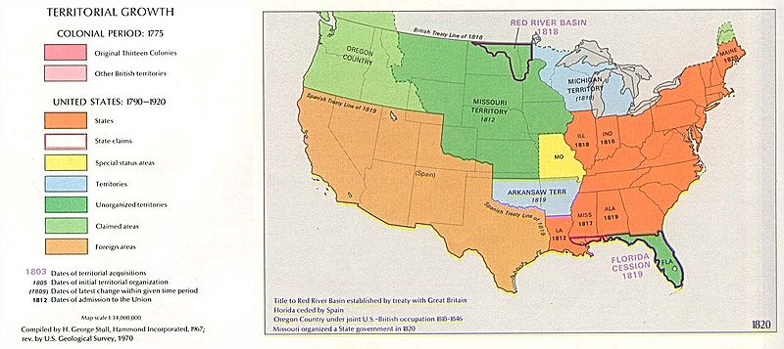

- The Monroe Doctrine (1823)
- The Election of 1824 and the “Corrupt Bargain”

Presidential Candidate | Party | Home State | Popular Vote^{(a)} |  | Electoral Vote
 |  |  | Count | Percentage
Andrew Jackson | Democratic-Republican | Tennessee | 151,271 | 41.3% | 99
John Quincy Adams | Democratic-Republican | Massachusetts | 113,122 | 30.9% | 84
William Harris Crawford | Democratic-Republican | Georgia | 40,856 | 11.2% | 41
Henry Clay | Democratic-Republican | Kentucky | 47,531 | 13.0% | 37
(Massachusetts unpledged electors) | (n/a) | (n/a) | 6,616 | 1.8% | 0
Other |  |  | 6,437 | 1.8% | 0
Total |  |  | 365,833 | 100.0% | 261
Needed to win |  |  |  |  | 131

- The Completion of the Erie Canal (1825)

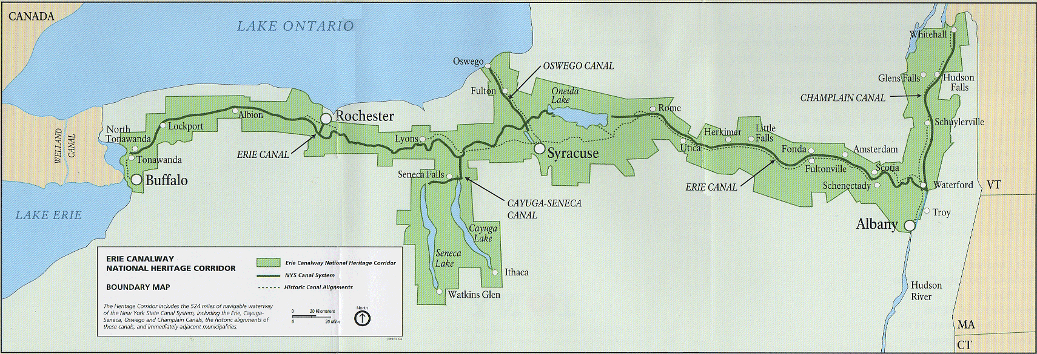

- The Completion of the National Road/Cumberland Road (1818)

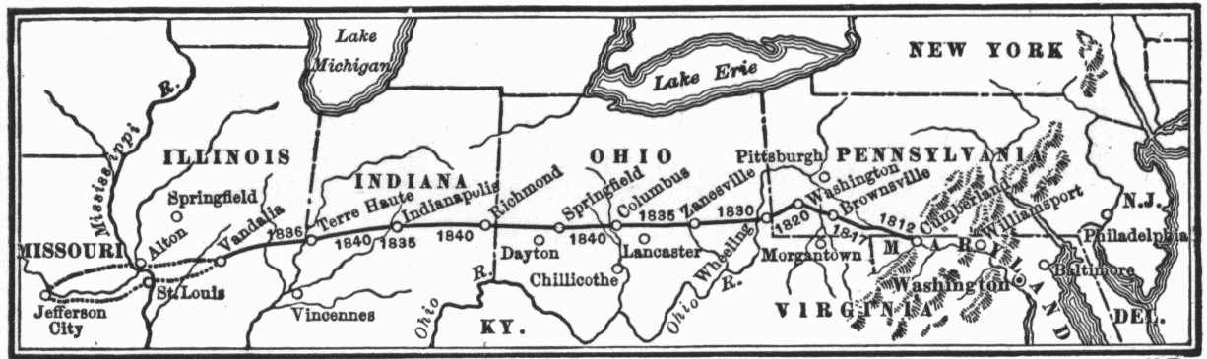

- The Dawn of the Industrial Revolution (1820’s)
- The “Tariff of Abominations” & The Nullification Crisis (1828)
- The Indian Removal Act (1832)
- The Bank Wars (1816 & 1836)
- The Stresses of Immigration (1840’s)

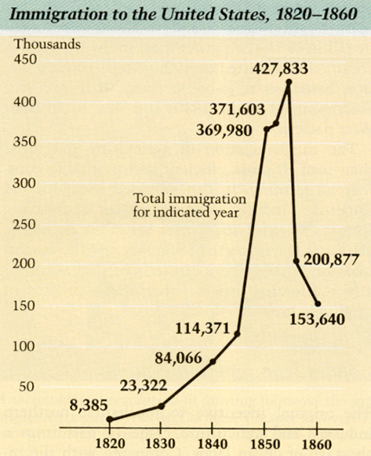

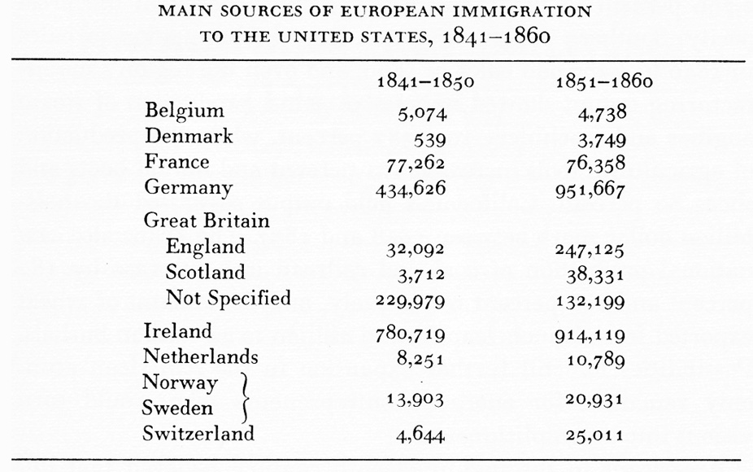

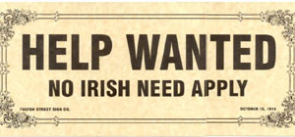

- The Second Great Awakening (1820-1850)
- Horace Mann’s Case for the Public Schools (1848)
- The Second Political Party System (1836- )
- Westward Expansion & Manifest Destiny (1803-1848)
  - The Louisiana Purchase (1803)
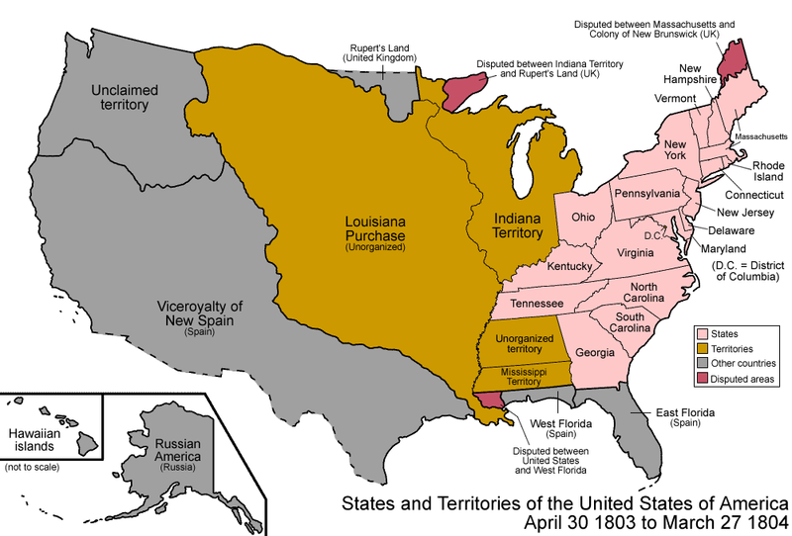

  - The Oregon Trail (1830’s)

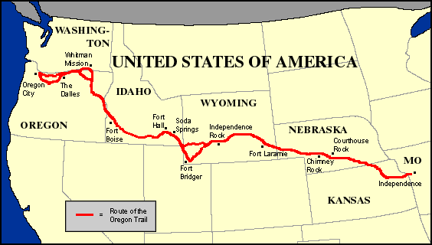

  - The Texas Crisis (1836)
  - The Mexican-American War (1846-1848)

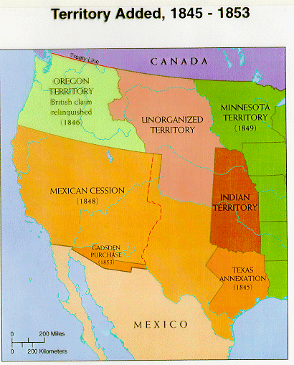

  - The Wilmot Proviso (1848)
- The “Peculiar Institution” of Slavery
  - The Gag Rule (1836 - )
  - Fitzhugh & the “Positive Good”
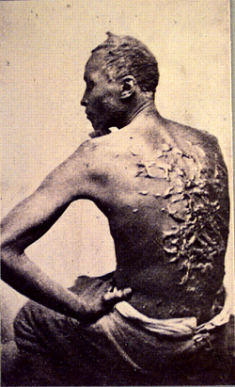

  - The Minstrels

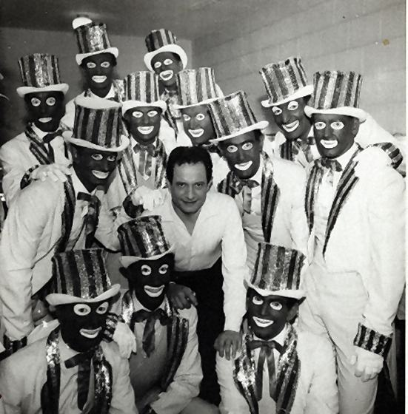

  - The Slave Trade
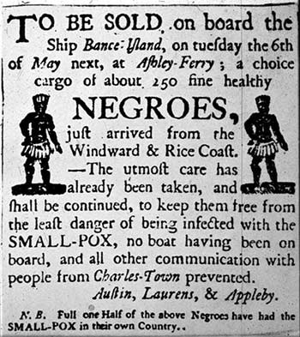

  - The Fugitive Slave Act (1850)
  - Dred Scott v. Sanford (1857)
- Rebellion Against the “Peculiar Institution”
  - The American Colonization Society
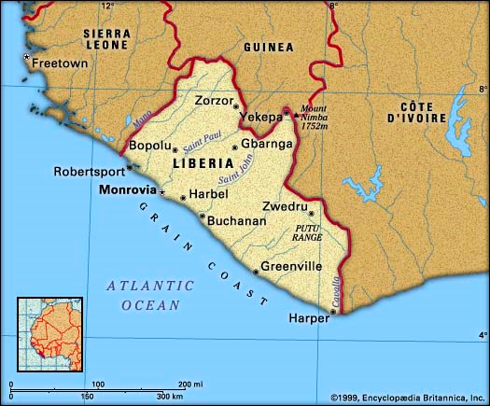

  - Gabriel Prosser
  - Denmark Vesey
  - Nat Turner
  - John Brown
  - The Underground Railroad

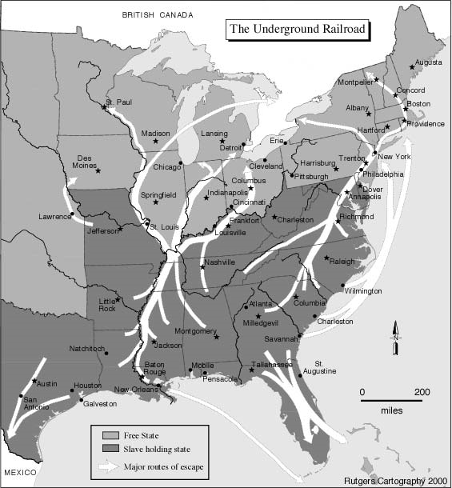

  - Walker’s Appeal & Garrison’s Liberator
  - Uncle Tom’s Cabin
- The Crisis 0f 1850, Clay’s Last Stand & The Compromise of 1850

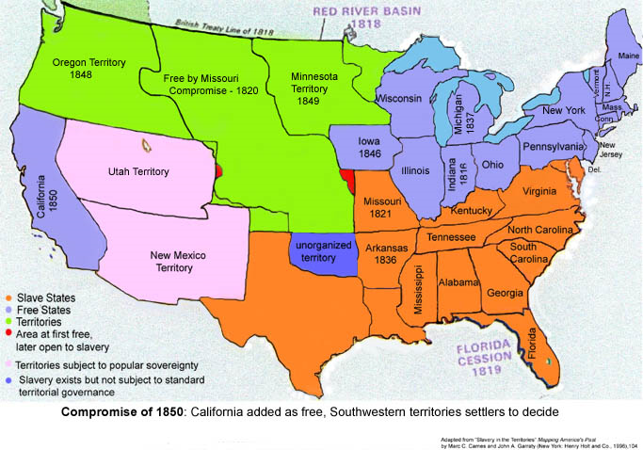
- The State of Kansas
  - The Kansas-Nebraska Act (1854)

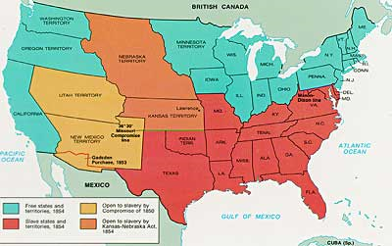

  - Bleeding Kansas (1856)

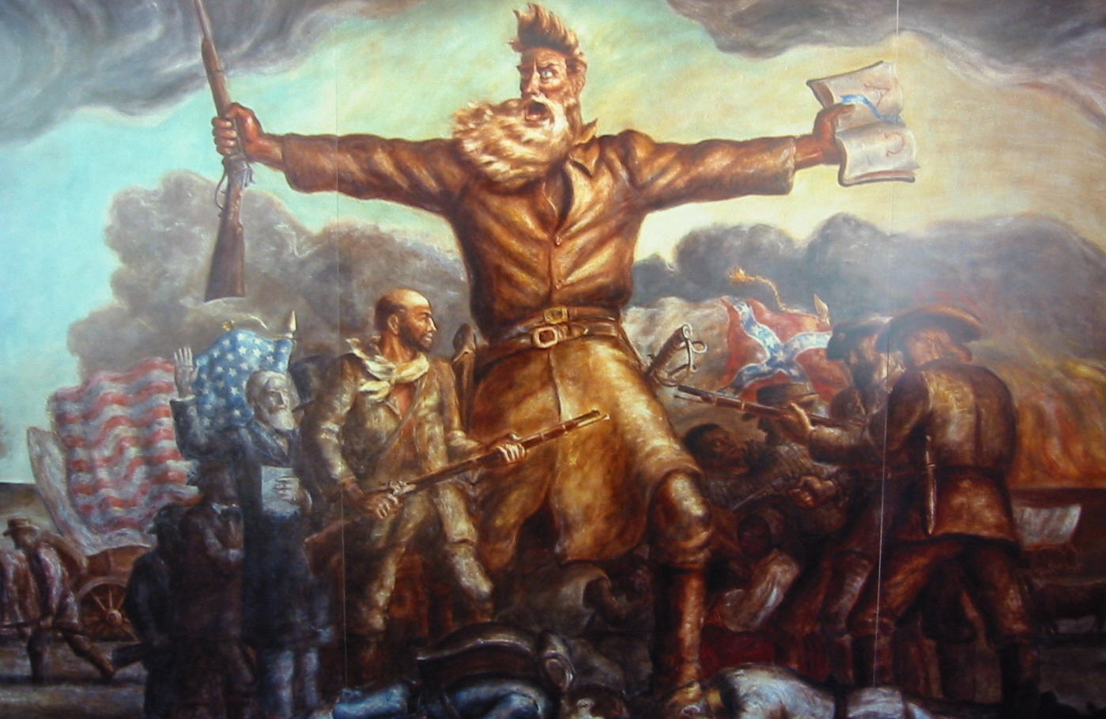

  - The Lecompton Constitution (1857)
- The Third Political Party System
  - Republicans
  - Free Soilers
  - Know Nothings
  - The Election of 1856

Results
Presidential candidate | Party | Home state | Popular vote^{(a)} |  | Electoral  vote
 |  |  | Count | Pct
James Buchanan | Democratic | Pennsylvania | 1,836,072 | 45.3% | 174
John Charles Frémont | Republican | California | 1,342,345 | 33.1% | 114
Millard Fillmore | American/Whig | New York | 873,053 | 21.6% | 8
Other |  |  | 3,177 | 0.1% | –
Total |  |  | 4,054,647 | 100% | 296
Needed to win |  |  |  |  | 149

  - The Election of 1860
Presidential candidate | Party | Home state | Popular vote^{(a)} |  | Electoral  vote
 |  |  | Count | Pct
Abraham Lincoln | Republican | Illinois | 1,865,908 | 39.8% | 180
John C. Breckinridge | Southern Democratic | Kentucky | 848,019 | 18.1% | 72
John Bell | Constitutional Union/Whig | Tennessee | 590,901 | 12.6% | 39
Stephen A. Douglas | Northern Democratic | Illinois | 1,380,202 | 29.5% | 12
Other |  |  | 531 | 0.0% | –
Total |  |  | 4,685,561 | 100% | 303
Needed to win |  |  |  |  | 152

- One Divisible Nation
  - The Failures of Crittenden’s Compromise
  - The Secession of South Carolina (21 December 1860)
  - The Confederate States of America (formed from Dec 1860- May 1861)
  - The Battle of Fort Sumter (11 April 1861)

